5/22/2021

Abdelrahman Adel

Abdelrahman.adel.elsayed@gmail.com

AI Diploma

Assessment Seven

Contents

Statistical Tests: 2

Types: 2

Choosing a parametric test: regression, comparison, or correlation 2

Choosing a nonparametric test 5

Use: 7

References 8

# Statistical Tests:

## Types:

### Choosing a parametric test: regression, comparison, or correlation

Parametric tests usually have stricter requirements than nonparametric tests, and are able to make stronger inferences from the data. They can only be conducted with data that adheres to the common assumptions of statistical tests.

|  |  |  |  |
| --- | --- | --- | --- |
|  | Predictor variable | Outcome variable | Research question example |
| [Simple linear regression](https://www.scribbr.com/statistics/simple-linear-regression/) | * Continuous * 1 predictor | * Continuous * 1 outcome | What is the effect of income on longevity? |
| [Multiple linear regression](https://www.scribbr.com/statistics/multiple-linear-regression/) | * Continuous * 2 or more predictors | * Continuous * 1 outcome | What is the effect of income and minutes of exercise per day on longevity? |
| Logistic regression | * Continuous | * Binary | What is the effect of drug dosage on the survival of a test subject? |

The most common types of parametric test include regression tests, comparison tests, and correlation tests.

**Regression tests**

Regression tests are used to**test cause-and-effect relationships**. They look for the effect of one or more continuous variables on another variable.

**Comparison tests**

Comparison tests look for **differences among group means**. They can be used to test the effect of a categorical variable on the [mean value](https://www.scribbr.com/statistics/mean/) of some other characteristic.

[T-tests](https://www.scribbr.com/statistics/t-test/) are used when comparing the means of precisely two groups (e.g. the average heights of men and women). [ANOVA](https://www.scribbr.com/statistics/one-way-anova/) and MANOVA tests are used when comparing the means of more than two groups (e.g. the average heights of children, teenagers, and adults).

|  |  |  |  |
| --- | --- | --- | --- |
|  | Predictor variable | Outcome variable | Research question example |
| Paired t-test | * Categorical * 1 predictor | * Quantitative * groups come from the same population | What is the effect of two different test prep programs on the average exam scores for students from the same class? |
| Independent t-test | * Categorical * 1 predictor | * Quantitative * groups come from different populations | What is the difference in average exam scores for students from two different schools? |
| ANOVA | * Categorical * 1 or more predictor | * Quantitative * 1 outcome | What is the difference in average pain levels among post-surgical patients given three different painkillers? |
| MANOVA | * Categorical * 1 or more predictor | * Quantitative * 2 or more outcome | What is the effect of flower species on petal length, petal width, and stem length? |

**Correlation tests**

Correlation tests **check whether two variables are related** without assuming cause-and-effect relationships.

These can be used to test whether two variables you want to use in (for example) a multiple regression test are autocorrelated.

|  |  |  |  |
| --- | --- | --- | --- |
|  | Predictor variable | Outcome variable | Research question example |
| Pearson’s *r* | Continuous | Continuous | How are latitude and temperature related? |

### Choosing a nonparametric test

Non-parametric tests don’t make as many assumptions about the data, and are useful when one or more of the common statistical assumptions are violated. However, the inferences they make aren’t as strong as with parametric tests.

|  |  |  |  |
| --- | --- | --- | --- |
|  | Predictor variable | Outcome variable | Use in place of… |
| Spearman’s *r* | * Quantitative | * Quantitative | Pearson’s *r* |
| Chi square test of independence | * Categorical | * Categorical | Pearson’s *r* |
| Sign test | * Categorical | * Quantitative | One-sample *t*-test |
| Kruskal–Wallis *H* | * Categorical * 3 or more groups | * Quantitative | ANOVA |
| ANOSIM | * Categorical * 3 or more groups | * Quantitative * 2 or more outcome variables | MANOVA |
| Wilcoxon Rank-Sum test | * Categorical * 2 groups | * Quantitative * groups come from different populations | Independent t-test |
| Wilcoxon Signed-rank test | * Categorical * 2 groups | * Quantitative * groups come from the same population | Paired t-test |
|  |  |  |  |

## Use:

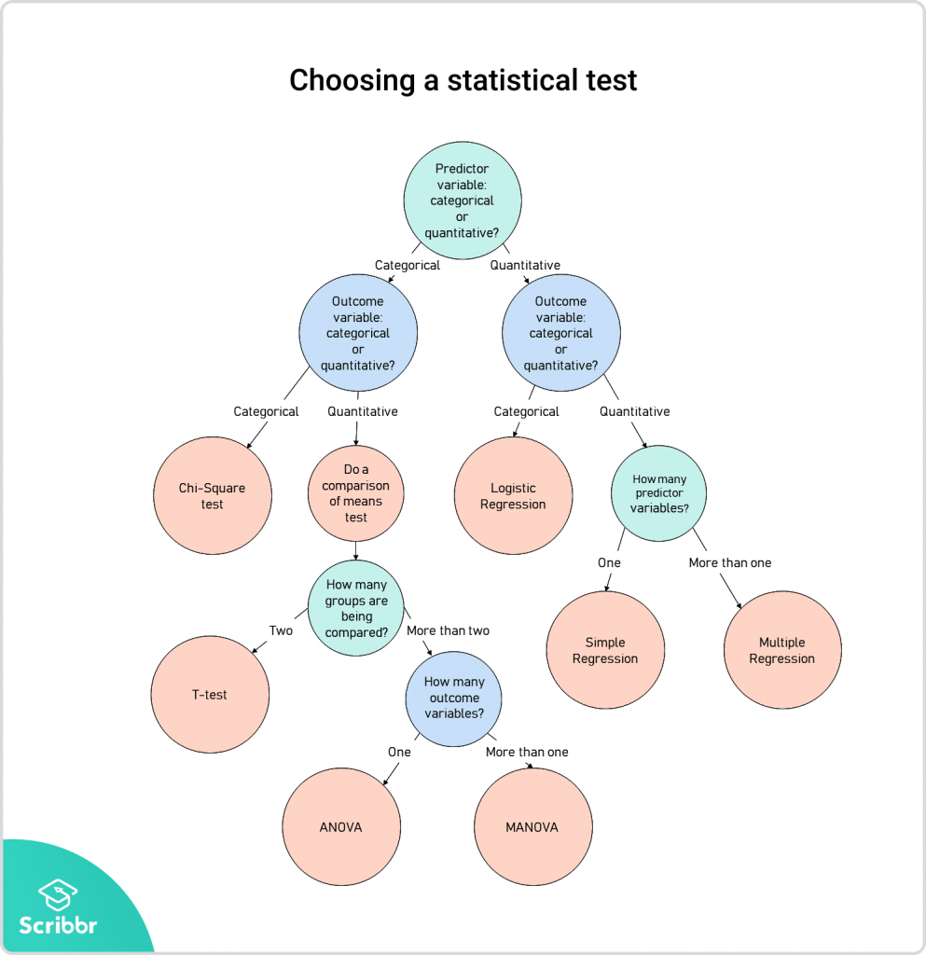

# References

|  |  |
| --- | --- |
| [1] | R.Bevans, "Scribbr," 28 12 2020. [Online]. Available: https://www.scribbr.com/statistics/statistical-tests/#:%7E:text=Statistical%20tests%20assume%20a%20null,predicted%20by%20the%20null%20hypothesis.. |